**EXECUÇÃO DO ALGORITMO DE DIJKSTRA**

REGINALDO GREGÓRIO DE SOUZA NETO

2252813

Exercício 1:

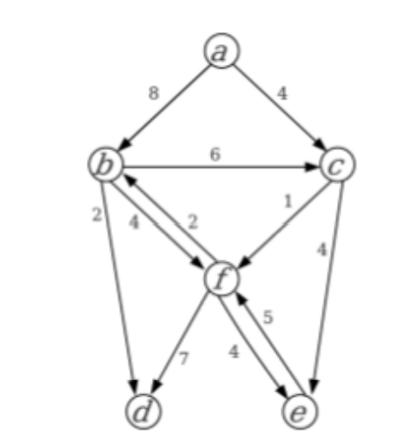

Nó inicial: A Nó final: D

DISTÂNCIAS PREDECESSORES

|  |  |
| --- | --- |
| A | 0 |
| B | inf |
| C | inf |
| D | inf |
| E | inf |
| F | inf |

|  |  |
| --- | --- |
| A | -1 |
| B | -1 |
| C | -1 |
| D | -1 |
| E | -1 |
| F | -1 |

DISTÂNCIAS PREDECESSORES

|  |  |
| --- | --- |
| A | 0 |
| B | 8 |
| C | 4 |
| D | inf |
| E | inf |
| F | inf |

|  |  |
| --- | --- |
| A | -1 |
| B | A |
| C | A |
| D | -1 |
| E | -1 |
| F | -1 |

DISTÂNCIAS PREDECESSORES

|  |  |
| --- | --- |
| A | 0 |
| B | 8 |
| C | 4 |
| D | inf |
| E | 8 |
| F | 5 |

|  |  |
| --- | --- |
| A | -1 |
| B | A |
| C | A |
| D | -1 |
| E | C |
| F | C |

DISTÂNCIAS PREDECESSORES

|  |  |
| --- | --- |
| A | 0 |
| B | 7 |
| C | 4 |
| D | 12 |
| E | 8 |
| F | 5 |

|  |  |
| --- | --- |
| A | -1 |
| B | F |
| C | A |
| D | F |
| E | C |
| F | C |

DISTÂNCIAS PREDECESSORES

|  |  |
| --- | --- |
| A | 0 |
| B | 7 |
| C | 4 |
| D | 10 |
| E | 8 |
| F | 5 |

|  |  |
| --- | --- |
| A | -1 |
| B | F |
| C | A |
| D | B |
| E | C |
| F | C |

MENOR CAMINHO:

A -> C -> F -> B -> D

4+1+2+2 = 9

Exercício 2:

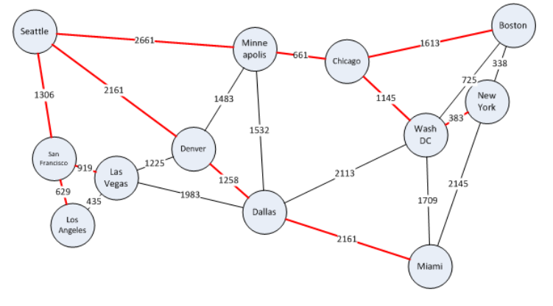

DISTÂNCIAS PREDECESSORES

|  |  |
| --- | --- |
| Seattle | 0 |
| San F | inf |
| Los A | inf |
| Las V | inf |
| Denver | inf |
| Minne | inf |
| Dallas | inf |
| Chicago | inf |
| WashDC | inf |
| NY | inf |
| Miami | inf |
| Boston | inf |

|  |  |
| --- | --- |
| Seattle | -1 |
| San F | -1 |
| Los A | -1 |
| Las V | -1 |
| Denver | -1 |
| Minne | -1 |
| Dallas | -1 |
| Chicago | -1 |
| WashDC | -1 |
| NY | -1 |
| Miami | -1 |
| Boston | -1 |

DISTÂNCIAS PREDECESSORES

|  |  |
| --- | --- |
| Seattle | 0 |
| San F | 1306 |
| Los A | 1935 |
| Las V | 2225 |
| Denver | 2161 |
| Minne | 2661 |
| Dallas | inf |
| Chicago | inf |
| WashDC | inf |
| NY | inf |
| Miami | inf |
| Boston | inf |

|  |  |
| --- | --- |
| Seattle | -1 |
| San F | Seattle |
| Los A | San F |
| Las V | San F |
| Denver | Seattle |
| Minne | Seattle |
| +Dallas | -1 |
| Chicago | -1 |
| WashDC | -1 |
| NY | -1 |
| Miami | -1 |
| Boston | -1 |

DISTÂNCIAS PREDECESSORES

|  |  |
| --- | --- |
| Seattle | 0 |
| San F | 1306 |
| Los A | 1935 |
| Las V | 2225 |
| Denver | 2161 |
| Minne | 2661 |
| Dallas | inf |
| Chicago | inf |
| WashDC | inf |
| NY | inf |
| Miami | inf |
| Boston | inf |

|  |  |
| --- | --- |
| Seattle | -1 |
| San F | Seattle |
| Los A | San F |
| Las V | San F |
| Denver | Seattle |
| Minne | Seattle |
| Dallas | -1 |
| Chicago | -1 |
| WashDC | -1 |
| NY | -1 |
| Miami | -1 |
| Boston | -1 |

DISTÂNCIAS PREDECESSORES

|  |  |
| --- | --- |
| Seattle | 0 |
| San F | 1306 |
| Los A | 1935 |
| Las V | 2225 |
| Denver | 2161 |
| Minne | 2661 |
| Dallas | 5789 |
| Chicago | inf |
| WashDC | inf |
| NY | inf |
| Miami | inf |
| Boston | inf |

|  |  |
| --- | --- |
| Seattle | -1 |
| San F | Seattle |
| Los A | San F |
| Las V | San F |
| Denver | Seattle |
| Minne | Seattle |
| Dallas | Denver |
| Chicago | -1 |
| WashDC | -1 |
| NY | -1 |
| Miami | -1 |
| Boston | -1 |

DISTÂNCIAS PREDECESSORES

|  |  |
| --- | --- |
| Seattle | 0 |
| San F | 1306 |
| Los A | 1935 |
| Las V | 2225 |
| Denver | 2161 |
| Minne | 2661 |
| Dallas | 4208 |
| Chicago | inf |
| WashDC | inf |
| NY | inf |
| Miami | inf |
| Boston | inf |

|  |  |
| --- | --- |
| Seattle | -1 |
| San F | Seattle |
| Los A | San F |
| Las V | San F |
| Denver | Seattle |
| Minne | Seattle |
| Dallas | Las V |
| Chicago | -1 |
| WashDC | -1 |
| NY | -1 |
| Miami | -1 |
| Boston | -1 |

DISTÂNCIAS PREDECESSORES

|  |  |
| --- | --- |
| Seattle | 0 |
| San F | 1306 |
| Los A | 1935 |
| Las V | 2225 |
| Denver | 2161 |
| Minne | 2661 |
| Dallas | 4193 |
| Chicago | 2292 |
| WashDC | inf |
| NY | inf |
| Miami | inf |
| Boston | inf |

|  |  |
| --- | --- |
| Seattle | -1 |
| San F | Seattle |
| Los A | San F |
| Las V | San F |
| Denver | Seattle |
| Minne | Seattle |
| Dallas | Minne |
| Chicago | Minne |
| WashDC | -1 |
| NY | -1 |
| Miami | -1 |
| Boston | -1 |

DISTÂNCIAS PREDECESSORES

|  |  |
| --- | --- |
| Seattle | 0 |
| San F | 1306 |
| Los A | 1935 |
| Las V | 2225 |
| Denver | 2161 |
| Minne | 2661 |
| Dallas | 4193 |
| Chicago | 2292 |
| WashDC | 4067 |
| NY | inf |
| Miami | inf |
| Boston | 3905 |

|  |  |
| --- | --- |
| Seattle | -1 |
| San F | Seattle |
| Los A | San F |
| Las V | San F |
| Denver | Seattle |
| Minne | Seattle |
| Dallas | Minne |
| Chicago | Minne |
| WashDC | Chicago |
| NY | -1 |
| Miami | -1 |
| Boston | Chicago |

DISTÂNCIAS PREDECESSORES

|  |  |
| --- | --- |
| Seattle | 0 |
| San F | 1306 |
| Los A | 1935 |
| Las V | 2225 |
| Denver | 2161 |
| Minne | 2661 |
| Dallas | 4193 |
| Chicago | 2292 |
| WashDC | 4067 |
| NY | 4243 |
| Miami | inf |
| Boston | 3905 |

|  |  |
| --- | --- |
| Seattle | -1 |
| San F | Seattle |
| Los A | San F |
| Las V | San F |
| Denver | Seattle |
| Minne | Seattle |
| Dallas | Minne |
| Chicago | Minne |
| WashDC | Chicago |
| NY | Boston |
| Miami | -1 |
| Boston | Chicago |

DISTÂNCIAS PREDECESSORES

|  |  |
| --- | --- |
| Seattle | 0 |
| San F | 1306 |
| Los A | 1935 |
| Las V | 2225 |
| Denver | 2161 |
| Minne | 2661 |
| Dallas | 3419 |
| Chicago | 2292 |
| WashDC | 4067 |
| NY | 4243 |
| Miami | 5776 |
| Boston | 3905 |

|  |  |
| --- | --- |
| Seattle | -1 |
| San F | Seattle |
| Los A | San F |
| Las V | San F |
| Denver | Seattle |
| Minne | Seattle |
| Dallas | Denver |
| Chicago | Minne |
| WashDC | Chicago |
| NY | Boston |
| Miami | WashDC |
| Boston | Chicago |

DISTÂNCIAS PREDECESSORES

|  |  |
| --- | --- |
| Seattle | 0 |
| San F | 1306 |
| Los A | 1935 |
| Las V | 2225 |
| Denver | 2161 |
| Minne | 2661 |
| Dallas | 4193 |
| Chicago | 2292 |
| WashDC | 4067 |
| NY | 4243 |
| Miami | 5776 |
| Boston | 3905 |

|  |  |
| --- | --- |
| Seattle | -1 |
| San F | Seattle |
| Los A | San F |
| Las V | San F |
| Denver | Seattle |
| Minne | Seattle |
| Dallas | Minne |
| Chicago | Minne |
| WashDC | Chicago |
| NY | Boston |
| Miami | WashDC |
| Boston | Chicago |

DISTÂNCIAS PREDECESSORES

|  |  |
| --- | --- |
| Seattle | 0 |
| San F | 1306 |
| Los A | 1935 |
| Las V | 2225 |
| Denver | 2161 |
| Minne | 2661 |
| Dallas | 3419 |
| Chicago | 2292 |
| WashDC | 4067 |
| NY | 4243 |
| Miami | 5776 |
| Boston | 3905 |

|  |  |
| --- | --- |
| Seattle | -1 |
| San F | Seattle |
| Los A | San F |
| Las V | San F |
| Denver | Seattle |
| Minne | Seattle |
| Dallas | Denver |
| Chicago | Minne |
| WashDC | Chicago |
| NY | Boston |
| Miami | WashDC |
| Boston | Chicago |

DISTÂNCIAS PREDECESSORES

|  |  |
| --- | --- |
| Seattle | 0 |
| San F | 1306 |
| Los A | 1935 |
| Las V | 2225 |
| Denver | 2161 |
| Minne | 2661 |
| Dallas | 3419 |
| Chicago | 2292 |
| WashDC | 4067 |
| NY | 4243 |
| Miami | 5776 |
| Boston | 3905 |

|  |  |
| --- | --- |
| Seattle | -1 |
| San F | Seattle |
| Los A | San F |
| Las V | San F |
| Denver | Seattle |
| Minne | Seattle |
| Dallas | Denver |
| Chicago | Minne |
| WashDC | Chicago |
| NY | Boston |
| Miami | WashDC |
| Boston | Chicago |

DISTÂNCIAS PREDECESSORES

|  |  |
| --- | --- |
| Seattle | 0 |
| San F | 1306 |
| Los A | 1935 |
| Las V | 2225 |
| Denver | 2161 |
| Minne | 2661 |
| Dallas | 3419 |
| Chicago | 2292 |
| WashDC | 4067 |
| NY | 4243 |
| Miami | 5776 |
| Boston | 3905 |

|  |  |
| --- | --- |
| Seattle | -1 |
| San F | Seattle |
| Los A | San F |
| Las V | San F |
| Denver | Seattle |
| Minne | Seattle |
| Dallas | Denver |
| Chicago | Minne |
| WashDC | Chicago |
| NY | Boston |
| Miami | WashDC |
| Boston | Chicago |

Seattle até Nova York = 4243 KM